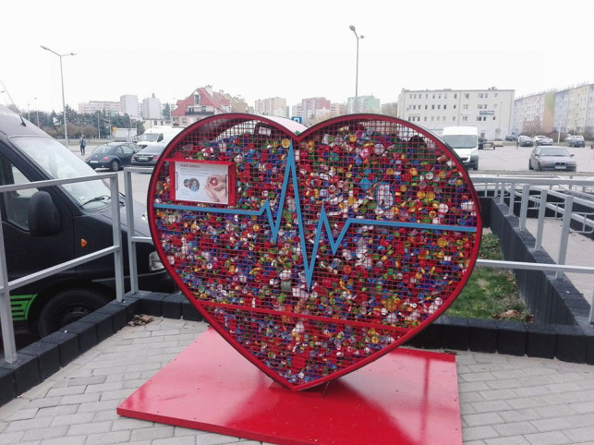https://www.google.pl/search?q=pojemnik+na+nakr%C4%99tki+zbi%C3%B3rka&sxsrf=ACYBGNSnaU8k1ngXNRct8H4v7TlKoAitlw:1574699478531&source=lnms&tbm=isch&sa=X&ved=2ahUKEwjV0K7Y5IXmAhWllosKHV33Cf0Q_AUoAXoECAwQAw&biw=1366&bih=632#imgrc=AU_DjkzLvPkz8M

